

**INTERENSHIP REPORT**

A report submitted in partial fulfillment of the requirements for the Award of Degree of

**BACHELOR OF COMPUTER APPLICATIONS**

**Under**

**BANGALORE CITY UNIVERSITY**



**Submitted By**

**Saumy Mishra**

**Under the Guidance of**

**Milan Patel Ms. Sreelakshmy**

**Mentor Assistant Professor**



**Signature Signature with Seal**

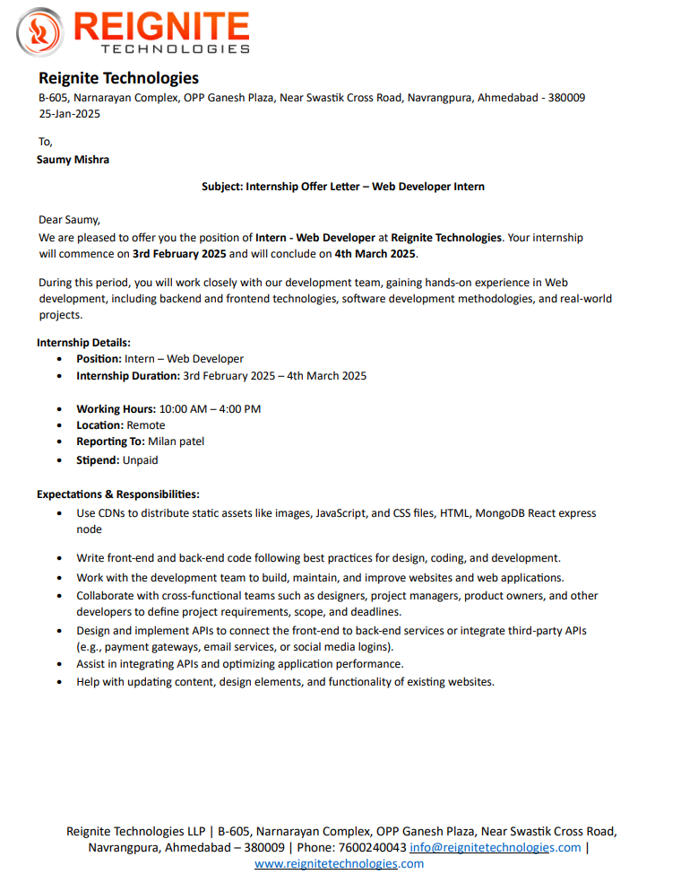

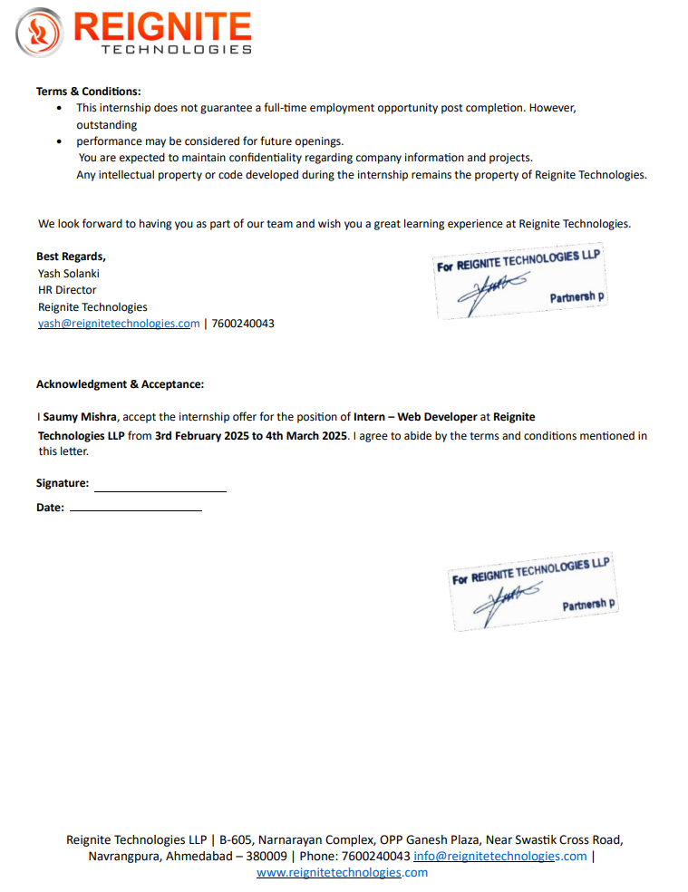

03/02/25

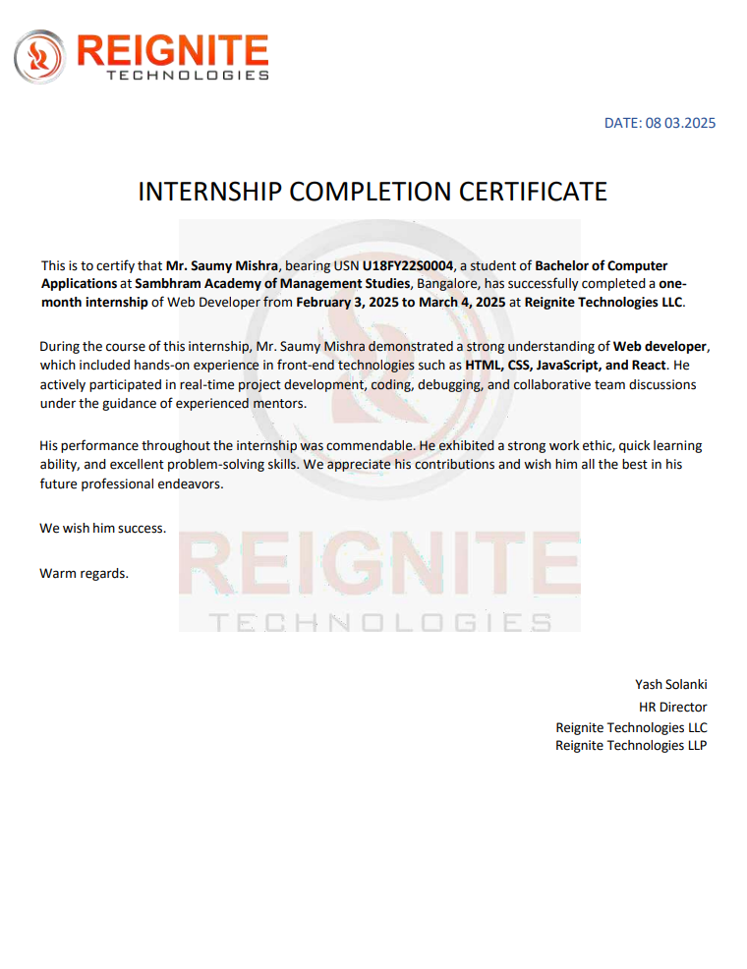

**DECLARATION**

I Mr. Saumy Mishra, Bearing Reg.No. U18FY22S0004 student of 6th Semester BCA, Sambhram Academy of Management Studies, Bengaluru, hereby declare that the Internship entitled ” Web Developer Intern” has been carried out by me under the supervision of Mr. Milan Patel, at Reignite Technologies and Internal guide Prof Ms. Sreelakshmy Department of Computer Applications, SAMS and submitted the as partial fullfilment of the Degree of Bachelor of Computer Applications by the Bangalore City University during the academic year 2024-25. This report has not been submitted to any other Organization/University for any award of degree or certificate.

Name of the Student: Saumy Mishra

Reg. No: U18FY22S0004

Signature:

Place: Bangalore Date:

**ACKNOWLEDGEMENT**

I have put in lot of efforts in this project. However, it would not have been possible without the support of many people. I would like to thank all of them. I express my sincere thanks to our honorable principal Wg.Cmdr.Dr.KSrinivas Rao, Principal for permitting me to undertake this project as part of our curriculum. I would like to thank Prof. Sunitha HoD, Department of Computer Applications, for her immense support and guidance throughout the project. I am indebted to my guide Prof Ms. Sreelakshmy, Department of Computer Applications, Sambhram Academy of Management Studies, Bengaluru, who has helped me with her useful guidance in completing this task through various stages. It gives me an immense pleasure to extend my thankfulness to all my Teaching fraternity of Department of Computer Applications for their suggestions and encouragement throughout my internship work. I also would like to express a deep sense of gratitude to Mr. Milan Patel, Reignite Technologies, Mentor for his continuous support, valuable information and challenging efforts in the right direction. Last, but not the least, I thank Almighty, my beloved parents and friends for their persistent encouragement.

Thanking You

Saumy Mishra

**INDEX**

|  |  |  |
| --- | --- | --- |
| **Sl. No** | **Particulars** | **Page Nos.** |
| 1 | Internship Report | 8 |
| 2 | About the Company | 10 |
| 3 | Weekly overview of the Internship | 11 |
| 4 | Skills acquired during the Internship | 13 |
| 5 | Conclusion | 23 |

**Internship Report**

**Abstract**

This report presents a detailed overview of the internship experience undertaken by the student, Saumy Mishra, at **Reignite Technologies LLP**, Ahmedabad, from **3rd February 2025 to 4th March 2025**, in the role of a **Web Developer Intern**. The internship provided an opportunity to apply academic knowledge in a real-world setting and gain practical exposure to the software development industry, specifically in the domain of web technologies.

The primary objective of the internship was to gain proficiency in both front-end and back-end web development frameworks and tools. During the internship, the student was actively involved in various development tasks, including creating and maintaining web pages, writing optimized code, and integrating APIs. The core technologies utilized included **HTML, CSS, JavaScript, React.js**. The intern also learned how to manage project workflows using collaborative tools and participated in team discussions, thereby gaining insight into agile development practices and version control systems like Git.

Working under the mentorship of experienced developers, the intern contributed to real-time projects that focused on user interface enhancement, functionality optimization, and performance tuning. Specific responsibilities involved implementing responsive design techniques, debugging existing code, and ensuring cross-browser compatibility of web applications. Additionally, exposure to RESTful APIs and third-party service integration added to the intern’s understanding of full-stack development practices.

This internship enabled the student to not only refine technical skills but also develop soft skills such as time management, communication, and team collaboration. Regular feedback sessions and guidance from senior developers ensured continuous learning and improvement. The experience has laid a strong foundation for a future career in web development, equipping the student with the knowledge, confidence, and professional discipline required in today’s competitive IT industry.

In conclusion, the internship at Reignite Technologies LLP served as a bridge between theoretical knowledge and its practical application, offering valuable insights into the professional world and shaping the intern’s career aspirations in the field of computer applications and software development.

**Internship Title:** Web Developer Intern  
**Name of the Student:** Saumy Mishra  
**Register Number:** U18FY22S0004  
**Company Name:** Reignite Technologies LLP  
**Start Date:** 3rd February 2025  
**End Date:** 4th March 2025

**ABOUT THE COMPANY**

**Reignite Technologies LLC** is a dynamic IT consulting and staffing company established in 2022, with a strong presence in both the **United States** and **India**. Headquartered in **Dover**, **Delaware**, and with an office in **Ahmedabad**, **Gujarat**, the company specializes in connecting exceptional **IT talent** with leading organizations across various industries. Reignite Technologies offers a wide range of services, including IT staffing solutions, custom software development, profile marketing, and career advancement services. Guided by its core values of **innovation**, **integrity**, **excellence**, and **collaboration**, the company is committed to delivering cutting-edge technology solutions tailored to the unique needs of its clients. Their mission is to empower businesses by leveraging technology to drive growth and innovation, while their vision focuses on becoming a catalyst for technological excellence across the globe. With a team of experienced professionals and a client-centric approach, Reignite Technologies continues to make significant strides in the IT industry by delivering high-quality services and fostering strong, long-term relationships with clients.

**WEEKLY OVERVIEW OF THE INTERNSHIP**

|  |  |  |  |
| --- | --- | --- | --- |
| **Week1** | **Date** | **Day** | **Topic/Module completed** |
| 1 | |  | | --- | | 03/02/2025 |  |  | | --- | |  | | Monday | |  | | --- | | Introduction to the company, internship orientation, tools setup |  |  | | --- | |  | |
| 2 | |  | | --- | | 04/02/2025 |  |  | | --- | |  | | Tuesday | |  | | --- | | Basics of HTML – Structure, Tags, Forms, and Semantics |  |  | | --- | |  | |
| 3 | |  | | --- | | 05/02/2025 |  |  | | --- | |  | | Wednesday | |  | | --- | | CSS Fundamentals – Styling, Box Model, and Selectors |  |  | | --- | |  | |
| 4 | |  | | --- | | 06/02/2025 | | Thursday | |  | | --- | | Layout Design with Flexbox and Grid | |
| 5 | |  | | --- | | 07/02/2025 |  |  | | --- | |  | | Friday | Responsive Design and Media Queries |

|  |  |  |  |
| --- | --- | --- | --- |
| **Week 2** | **Date** | **Day** | **Topic/Module completed** |
| 1 | |  | | --- | | 10/02/2025 |  |  | | --- | |  | | Monday | |  | | --- | | JavaScript Basics – Syntax, Variables, Data Types |  |  | | --- | |  | |
| 2 | |  | | --- | | 11/02/2025 |  |  | | --- | |  | | Tuesday | |  | | --- | | Functions, Loops, and Conditionals in JavaScript |  |  | | --- | |  | |
| 3 | |  | | --- | | 12/02/2025 |  |  | | --- | |  | | Wednesday | |  | | --- | | DOM Manipulation and Event Handling |  |  | | --- | |  | |
| 4 | |  | | --- | | 13/02/2025 |  |  | | --- | |  | | Thursday | |  |  | | --- | --- | | JavaScript Form Validation | | |  | |
| 5 | |  | | --- | | 14/02/2025 |  |  | | --- | |  | | Friday | Scope, Closures, and Hoisting |
|  |  |  |  |
| **Week 3** | **Date** | **Day** | **Topic/Module completed** |
| 1 | |  | | --- | | 17/02/2025 |  |  | | --- | |  | | Monday | |  |  | | --- | --- | | Introduction to React.js – Components and JSX | | |  | |
| 2 | |  | | --- | | 18/02/2025 |  |  | | --- | |  | | Tuesday | |  |  | | --- | --- | | State and Props in React | | |  | |
| 3 | |  | | --- | | 19/02/2025 |  |  | | --- | |  | | Wednesday | |  |  | | --- | --- | | React Hooks: useState, useEffect | | |  | |
| 4 | |  | | --- | | 20/02/2025 |  |  | | --- | |  | | Thursday | |  |  | | --- | --- | | Handling User Inputs and Forms in React | | |  | |
| 5 | |  | | --- | | 21/02/2025 |  |  | | --- | |  | | Friday | Routing with React Router and Simple Navigation Setup |

|  |  |  |  |
| --- | --- | --- | --- |
| **Week 4** | **Date** | **Day** | **Topic/Module completed** |
| 1 | |  | | --- | | 24/02/2025 |  |  | | --- | |  | | Monday | |  | | --- | | Final Project Setup: React-based UI | |  |  |  | | --- | |  | |
| 2 | |  | | --- | | 25/02/2025 |  |  | | --- | |  | | Tuesday | |  | | --- | | Component Reusability and Styling in React | |  |  |  | | --- | |  | |
| 3 | |  | | --- | | 26/02/2025 |  |  | | --- | |  | | Wednesday | |  | | --- | | Debugging and Performance Optimization in React | |  |  |  | | --- | |  | |
| 4 | |  | | --- | | 27/02/2025 |  |  | | --- | |  | | Thursday | |  | | --- | | Responsive Testing and Cross-Browser Compatibility |  |  | | --- | |  | |
| 5 | |  | | --- | | 28/02/2025 |  |  | | --- | |  | | Friday | Final Project Review and UI Enhancements |

**DETAILED DESCRIPTION OF THE SKILLS ACQUIRED DURING THE INTERNSHIP**

During my one-month internship as a Web Developer Intern at Reignite Technologies LLP, I had the opportunity to immerse myself in real-world web development projects that significantly enriched both my technical competencies and professional work ethic. This internship served as a pivotal step in transitioning from academic knowledge to practical application, particularly in the realm of frontend development. My responsibilities revolved around the implementation of responsive and interactive user interfaces using core technologies such as HTML, CSS, JavaScript, and React.js.

A substantial portion of my time was dedicated to enhancing static web designs by applying semantic HTML and modular CSS principles. I became proficient in writing clean, maintainable code and structuring HTML elements to ensure accessibility and compatibility across different browsers. CSS was a key focus area, and I learned to employ Flexbox and Grid layouts efficiently, along with incorporating animations and transitions to improve the visual appeal and user experience of web pages.

JavaScript played a central role in bringing interactivity to the interfaces. I deepened my understanding of key concepts such as event handling, DOM manipulation, and asynchronous programming through real-world tasks. Moreover, I got hands-on experience with ES6 features like arrow functions, destructuring, and template literals, which helped streamline the development process.

The most transformative aspect of the internship was working with React.js. I learned the fundamentals of component-based architecture, state and props management, and how to use hooks such as useState and useEffect to handle application logic effectively. Through collaborative tasks and individual assignments, I developed reusable components and integrated RESTful APIs to fetch and display dynamic content. I also became familiar with tools and practices such as version control using Git, code reviews, and debugging workflows, all of which are essential in a professional development environment.

Beyond technical skills, the internship fostered my ability to work in a team, meet deadlines, and communicate effectively with mentors and peers. Daily stand-up meetings and feedback sessions provided insights into agile development practices and helped me align my work with project goals.

Overall, my time at Reignite Technologies LLP was an invaluable learning experience that equipped me with both the confidence and capability to contribute meaningfully to frontend development projects. It also reinforced my passion for building intuitive and efficient user interfaces and laid a strong foundation for my future career in web development.

**1. HTML (HyperText Markup Language)**

During the early phase of my internship at Reignite Technologies LLP, I focused on building a strong foundation in HTML through hands-on tasks and mentorship. Key areas of learning included:

* **Semantic HTML Elements:**
  + Used tags like <header>, <footer>, <section>, and <article> to create meaningful, accessible page structures.
  + Improved SEO and content clarity by organizing elements semantically**.**
* **Form Handling:**
  + Implemented forms using <input>, <textarea>, <select>, and <button>.
  + Applied attributes such as required, placeholder, pattern, and type for validation and user guidance.
* **Embedding Media:**
  + Learned to embed images, videos, and audio using <img>, <video>, <audio>, and <iframe>.
  + Gained experience in optimizing media for better performance and user experience.
* **Hyperlinks and Navigation:**
  + Created internal and external links using <a> tags.
  + Built simple navigation menus and understood link hierarchy and user flow.
* **Tables and Lists:**
  + Structured data using <table>, <thead>, <tbody>, and <tr>.
  + Organized content with <ul>, <ol>, and <li> for clear presentation.
* **Practical Application:**
  + Built several static web pages incorporating all the above elements.
  + Focused on writing clean, well-organized code aligned with industry standards.

This foundational knowledge in HTML prepared me to move confidently into styling with CSS and interactive design with JavaScript and React.js.

**2. CSS (Cascading Style Sheets)**

My second major area of development was in CSS, which I used to enhance the visual design and layout of web pages. Key concepts and skills acquired include:

* **Selectors and specificity**: Learning how to target HTML elements using class, ID, and attribute selectors efficiently.
* **Box model**: Mastering margin, border, padding, and content layout principles.
* **Layout techniques**:
  + **Flexbox**: Aligning and distributing elements within a container, using properties such as justify-content, align-items, and flex-direction.
  + **CSS Grid**: Organizing content in rows and columns for complex layouts.
* **Media queries**: Making responsive designs that adapt to various screen sizes, ensuring mobile compatibility.
* **Styling components**: Customizing buttons, forms, modals, and navigation bars with consistent aesthetics.
* **Transitions and animations**: Adding smooth hover effects, image fades, and UI transitions.

I also learned to use developer tools to inspect styles, debug CSS issues, and adjust layouts in real time.

**3. JavaScript (Core Programming and DOM Manipulation)**

JavaScript was a crucial part of the internship, as it enabled me to add interactivity and dynamic behavior to web pages. My JavaScript learning covered both fundamental concepts and practical applications, including:

* **Variables and Data Types**: let, const, primitive and reference types.
* **Operators and Control Flow**: Conditional statements (if, else, switch) and loops (for, while, forEach).
* **Functions**: Declaring and invoking functions, including arrow functions and callback functions.
* **Scope and Closures**: Understanding how variables behave in different contexts.
* **DOM Manipulation**:
  + Accessing elements using methods like getElementById, querySelector, etc.
  + Modifying content and attributes dynamically.
  + Creating, appending, and removing elements using JavaScript.
* **Event Handling**: Responding to user interactions such as clicks, form submissions, and keypresses using addEventListener.

This knowledge allowed me to make pages interactive, such as validating forms on the client side and creating dynamic menus and tabs.

**4. React.js (Frontend JavaScript Library)**

A significant portion of the internship was dedicated to understanding **React**, one of the most widely used frontend libraries in the industry. Under guided supervision, I learned to build user interfaces using React’s component-based architecture:

* **JSX Syntax**: Embedding HTML within JavaScript and understanding how it is transpiled.
* **Functional Components**: Creating reusable UI components with clean structure.
* **Props and State**:
  + Passing data between components using props.
  + Managing component data dynamically using the useState hook.
* **React Hooks**:
  + **useState**: For managing local component state.
  + **useEffect**: For handling side effects such as loading data or responding to updates.
* **Event Handling in React**: Managing user interactions like button clicks and form input changes.
* **Conditional Rendering and Lists**: Displaying dynamic content using JavaScript conditions and mapping through arrays.
* **Routing with React Router**: Navigating between pages in a single-page application using <Route>, <Link>, and useNavigate.

I was also introduced to concepts such as component lifecycle, form handling, and UI libraries that can be used to speed up development.

**5. UI/UX Design Principles**

In addition to technical development, my internship at Reignite Technologies LLP emphasized the importance of designing with the end user in mind. I was encouraged to adopt a user-centric approach and integrate UI/UX design principles into every project. This broadened my understanding of how visual and functional elements contribute to overall user satisfaction.

* **Accessibility Awareness:**I learned how to design interfaces that are inclusive and usable for all users, including those with disabilities. This involved applying appropriate color contrasts, ensuring text readability, and enabling keyboard navigability. I also gained awareness of ARIA roles and semantic HTML to support assistive technologies.
* **Consistency in Design:**A major takeaway was the importance of maintaining uniformity in fonts, color schemes, button styles, and spacing throughout the application. Consistency helps users develop intuitive expectations and reduces cognitive load, making interfaces more predictable and easier to navigate.
* **Responsive and Mobile-First Design:**I applied responsive design principles to ensure applications worked seamlessly across different screen sizes and devices. Embracing a mobile-first approach, I learned to prioritize content and features for smaller screens before scaling up, improving performance and usability for a broader audience.
* **Iterative Design Through User Feedback:**I participated in basic user testing and feedback cycles, learning how to analyze user behavior and incorporate feedback to refine interface elements. This iterative process helped me understand which design choices enhanced or hindered usability, allowing for continuous improvement.

These UI/UX principles deeply influenced how I approached frontend development. They taught me to look beyond functionality and consider how users interact with and experience the product, resulting in more intuitive, accessible, and visually cohesive web applications.

**6. Tools and Workflow Practices**

During my internship at Reignite Technologies LLP, I was introduced to essential tools and workflow practices that are commonly used in professional web development environments. These tools not only improved my efficiency but also helped me align my work with industry standards.

* **Version Control with Git:**I gained hands-on experience using Git for tracking code changes and collaborating efficiently. I learned how to clone repositories, commit changes, push updates to remote repositories, and work with branch-based workflows. This gave me a solid understanding of maintaining clean commit histories and resolving merge conflicts.
* **Code Editors and Extensions:**My primary development environment was Visual Studio Code, where I explored various productivity-enhancing extensions. I regularly used Prettier for automatic code formatting and ESLint for maintaining code quality and consistency. These tools helped enforce best practices and reduce errors during development.
* **Browser Developer Tools:**I used Chrome DevTools extensively to inspect HTML/CSS elements, monitor network activity, and debug JavaScript errors. These tools proved invaluable in identifying layout issues, checking responsive behavior, and optimizing performance.
* **Deployment Overview:**I gained a basic understanding of how frontend projects are deployed using platforms like GitHub Pages and Netlify. This included learning how to host static sites, manage build settings, and monitor live site behavior after deployment.

These tools and practices equipped me with the workflow skills necessary for modern web development. They helped me work more systematically, debug more effectively, and collaborate in ways that mirror real-world software teams.

**7. Soft Skills and Professional Development**

In addition to technical competencies, the internship contributed to personal and professional growth:

* **Communication**: Attending team meetings, sharing updates, and receiving feedback constructively.
* **Time Management**: Working independently on tasks with deadlines, following daily progress trackers.
* **Collaboration**: Participating in code reviews and discussions, aligning with team members on UI approaches.
* **Problem-Solving**: Debugging complex issues in layouts and logic, using systematic approaches and documentation.

**CONCLUSION**

My internship at **Reignite Technologies LLP** served as a significant stepping stone in my journey toward becoming a professional **Web Developer**. It provided me with a well-rounded introduction to modern frontend development, combining theoretical concepts with practical, real-world application. Working on live projects allowed me to see firsthand how the technologies I had studied—**HTML, CSS, JavaScript,** and **React.js** — come together to create responsive and dynamic user interfaces.

This hands-on experience not only deepened my understanding of coding but also honed my **problem-solving abilities** and **critical thinking skills**. I became more comfortable working within a collaborative environment, participating in team discussions, code reviews, and daily stand-ups. These interactions gave me a clearer understanding of **Agile methodologies** and how team dynamics contribute to successful project delivery.

Moreover, I developed an appreciation for the complete **Software Development Lifecycle**, from planning and designing to development, testing, and deployment. Exposure to industry tools such as **Git**, **Visual Studio Code**, and browser **DevTools** gave me a realistic view of how professional developers work and the importance of clean, maintainable code.

Perhaps most importantly, the internship boosted my confidence in my ability to contribute meaningfully to web development projects. It affirmed my interest in frontend development and solidified my commitment to pursuing a career in this field. I now feel well-prepared to take on more advanced challenges and continue learning as I grow in this ever-evolving industry.